1. FINDING WHERE THE CHECK-IN TIME IS 329:-

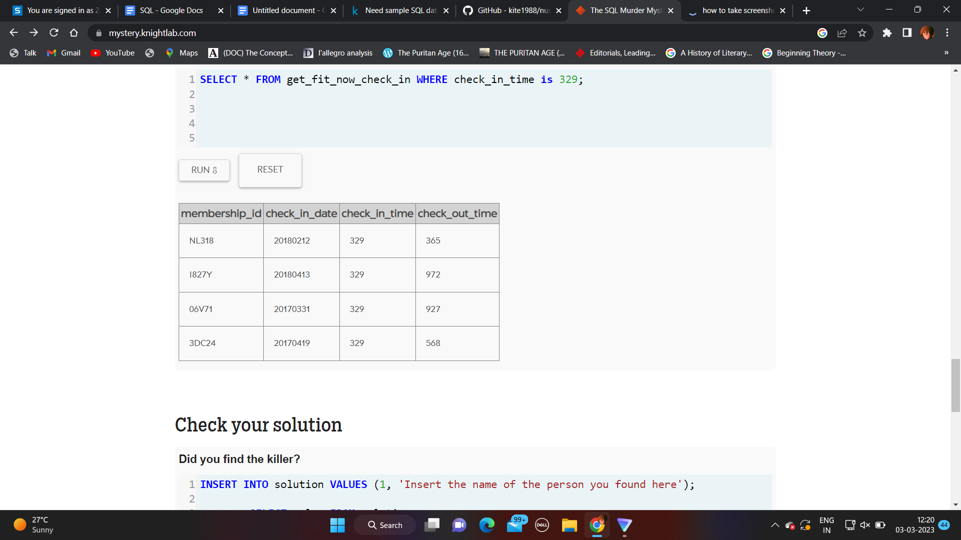

SELECT * FROM get_fit_now_check_in WHERE check_in_time is 329;

2. Finding where the income is equal to 70000

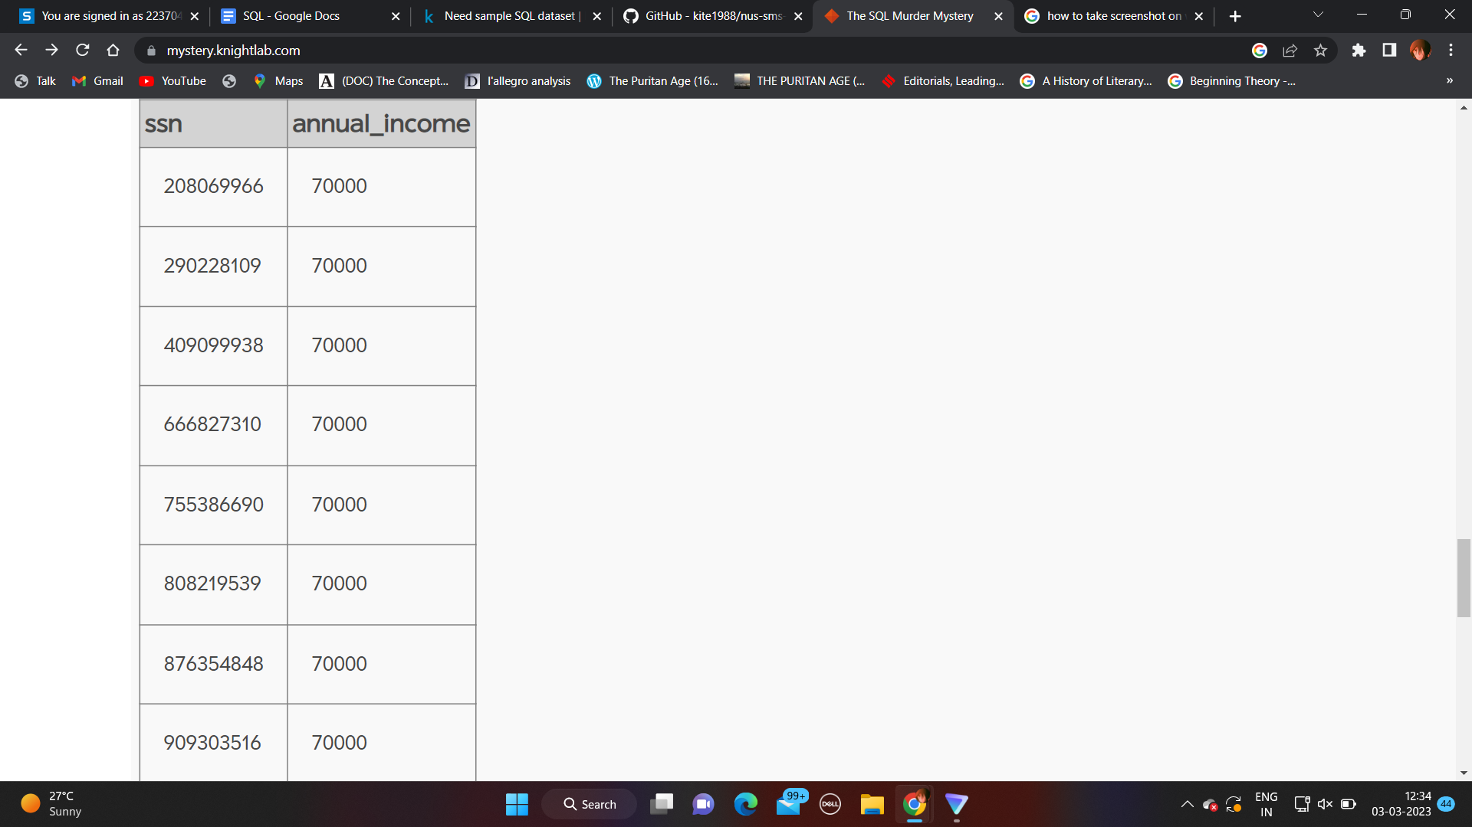

SELECT * FROM income WHERE annual_income = "70000";

3. Finding where the person_id is equal to 65076

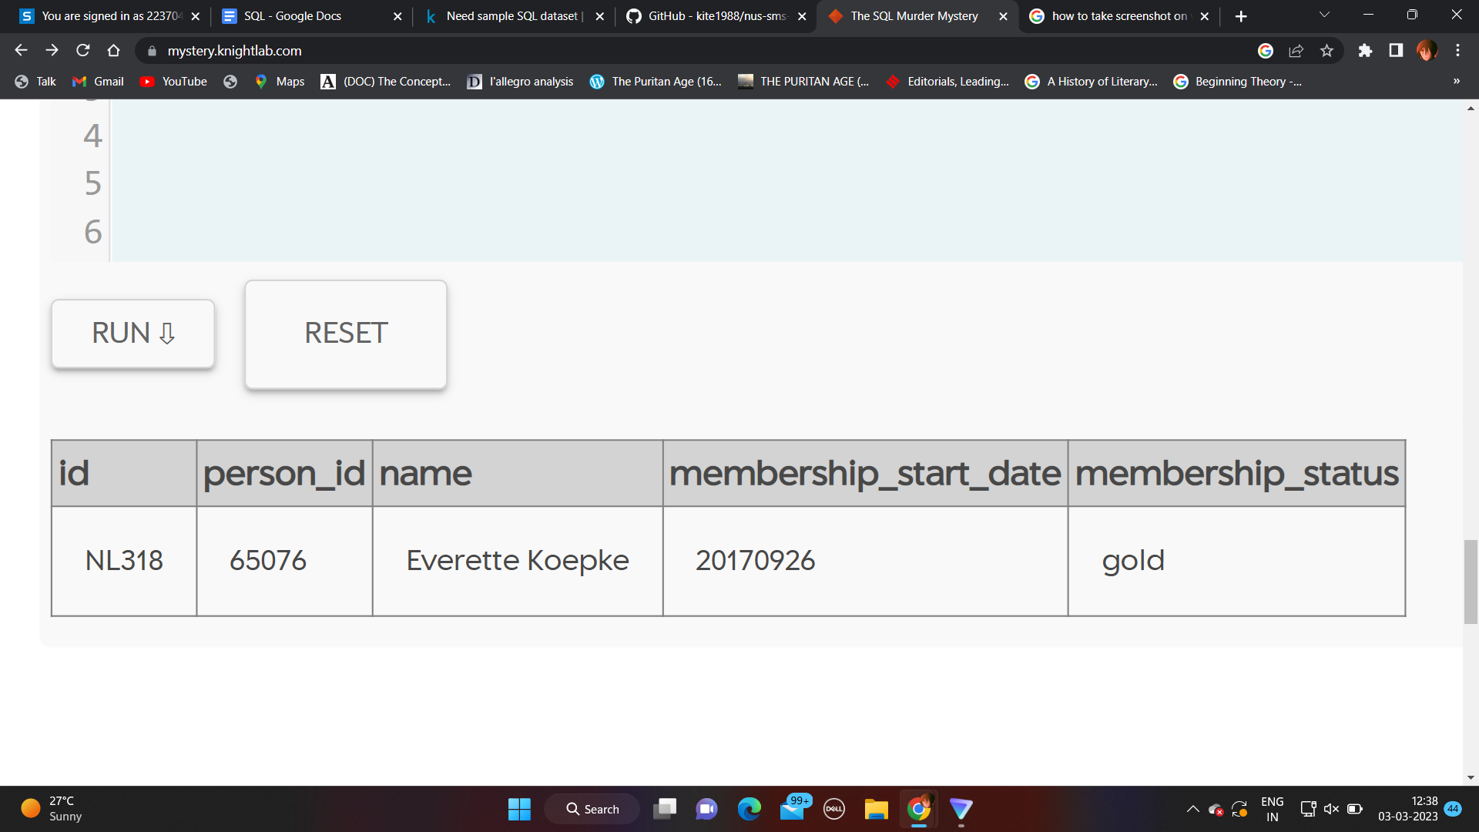

4. Finding where the address_street_name is equal to Bankhall Ave

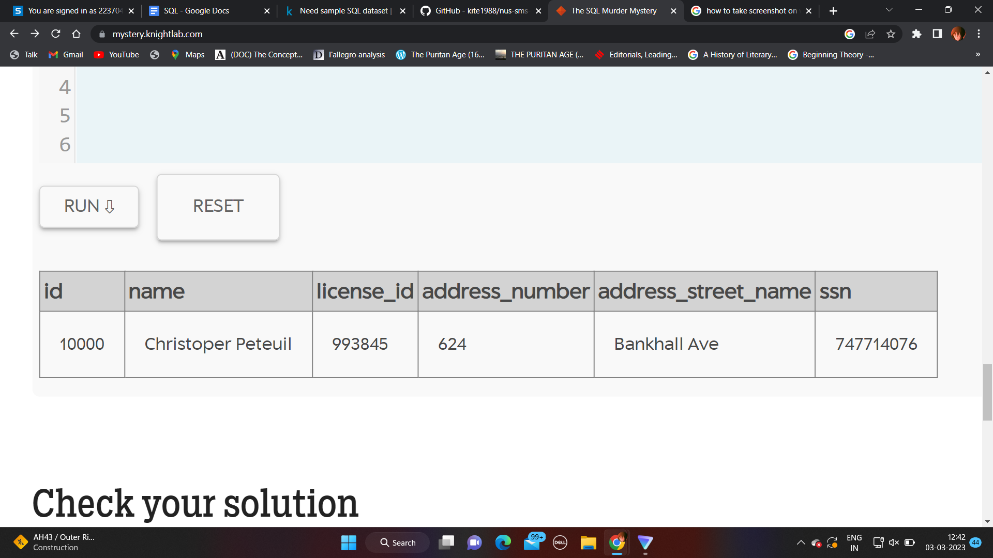

SELECT * FROM person Where address_street_name = 'Bankhall Ave'

5. Finding where the person_id is 86208

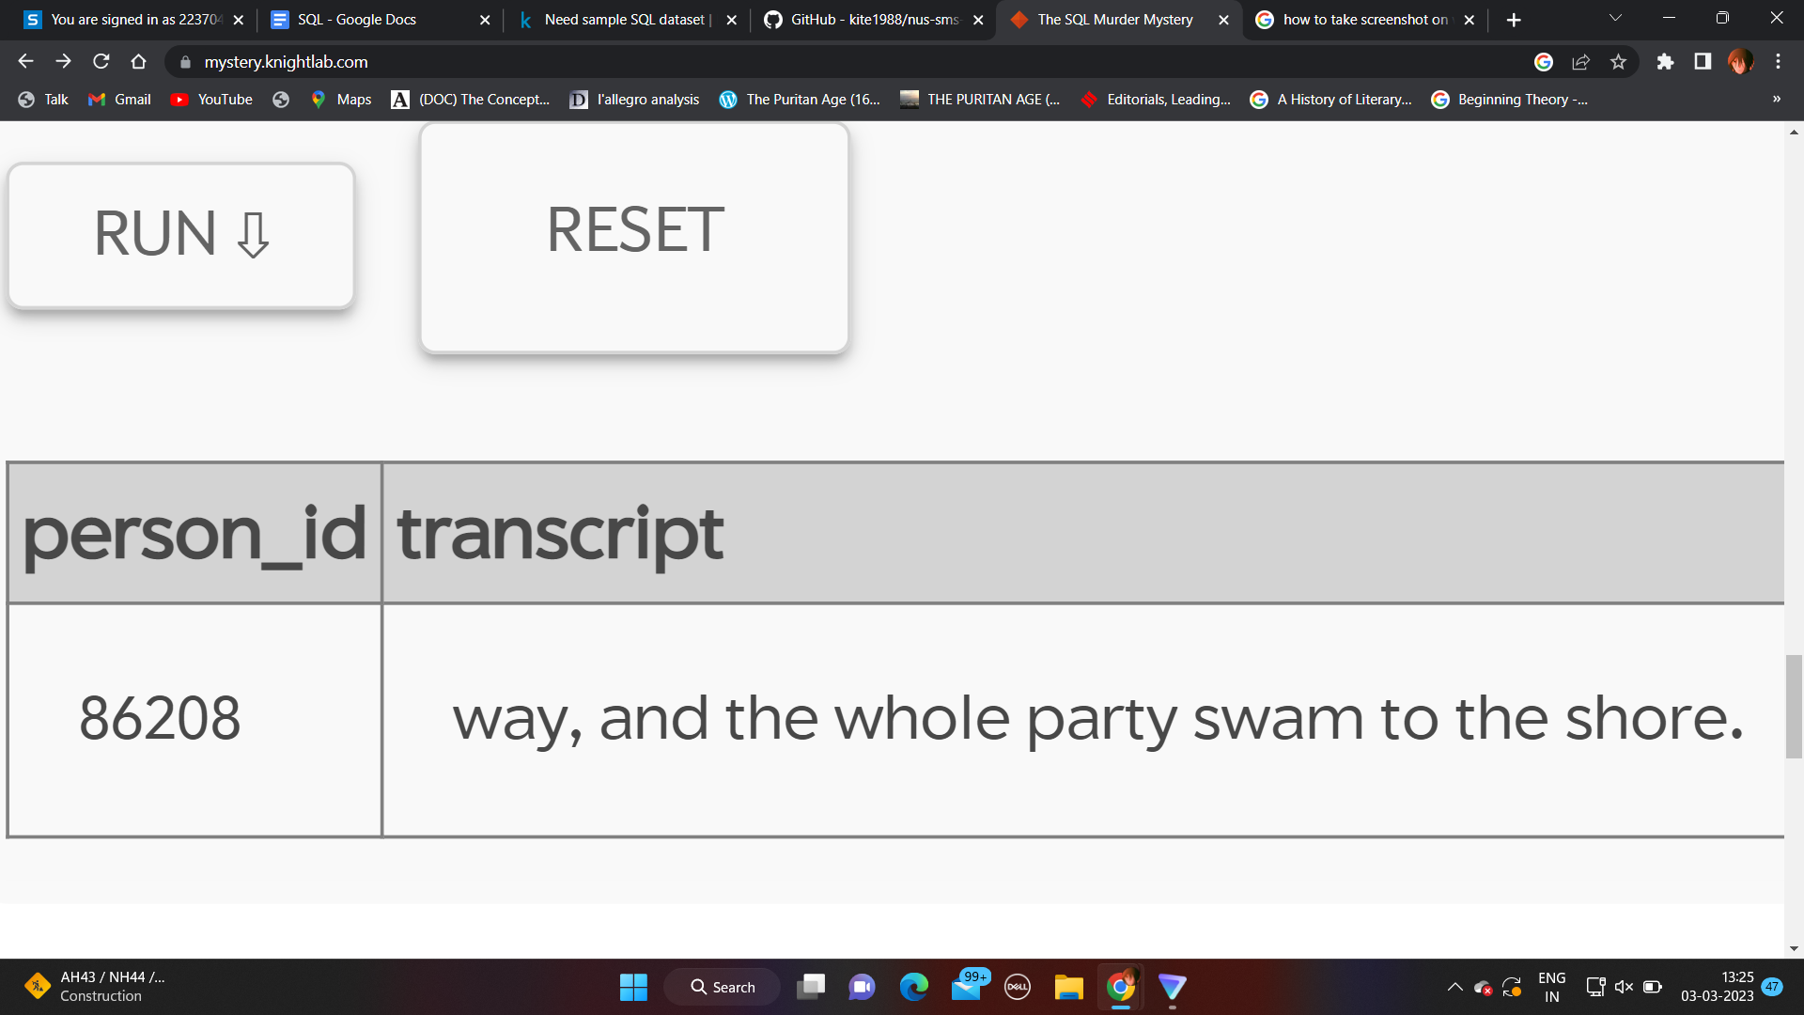

SELECT*FROM interview WHERE person_id = "86208";

6. JOINING TWO TABLES

TABLE NAME: Salesman

salesman_id | name | city | commission

-------------+------------+----------+------------

5001 | James Hoog | New York | 0.15

5002 | Nail Knite | Paris | 0.13

5005 | Pit Alex | London | 0.11

5006 | Mc Lyon | Paris | 0.14

5007 | Paul Adam | Rome | 0.13

5003 | Lauson Hen | San Jose | 0.12

TABLE NAME: Customers

customer_id | cust_name | city | grade | salesman_id

-------------+----------------+------------+-------+-------------

3002 | Nick Rimando | New York | 100 | 5001

3007 | Brad Davis | New York | 200 | 5001

3005 | Graham Zusi | California | 200 | 5002

3008 | Julian Green | London | 300 | 5002

3004 | Fabian Johnson | Paris | 300 | 5006

3009 | Geoff Cameron | Berlin | 100 | 5003

3003 | Jozy Altidor | Moscow | 200 | 5007

3001 | Brad Guzan | London | 300 | 5005

SELECT* FROM SALESMAN, Customers LEFT JOIN customer_id = salesman_id

7. Finding the top 5 IDs in ascending order

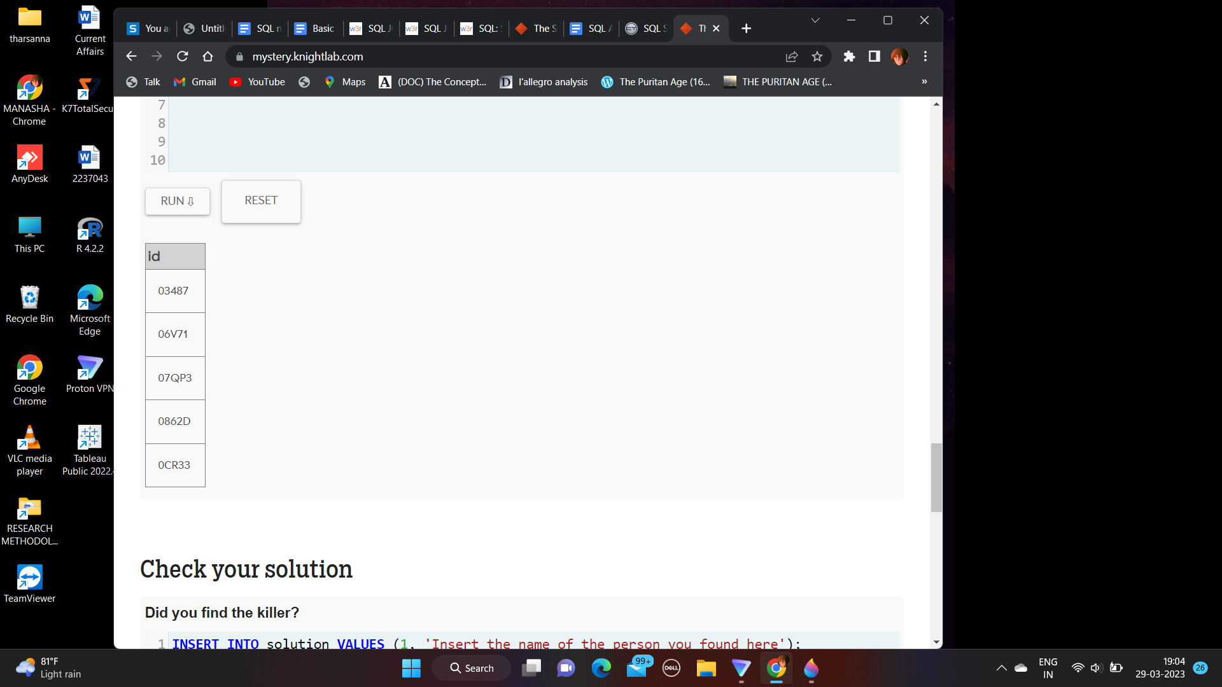

SELECT id

FROM get_fit_now_member

ORDER BY id ASC

LIMIT 5;

8. Where the address number is greater than 5, limited by 3

SELECT * from person

WHERE address_number < 5

LIMIT 3;

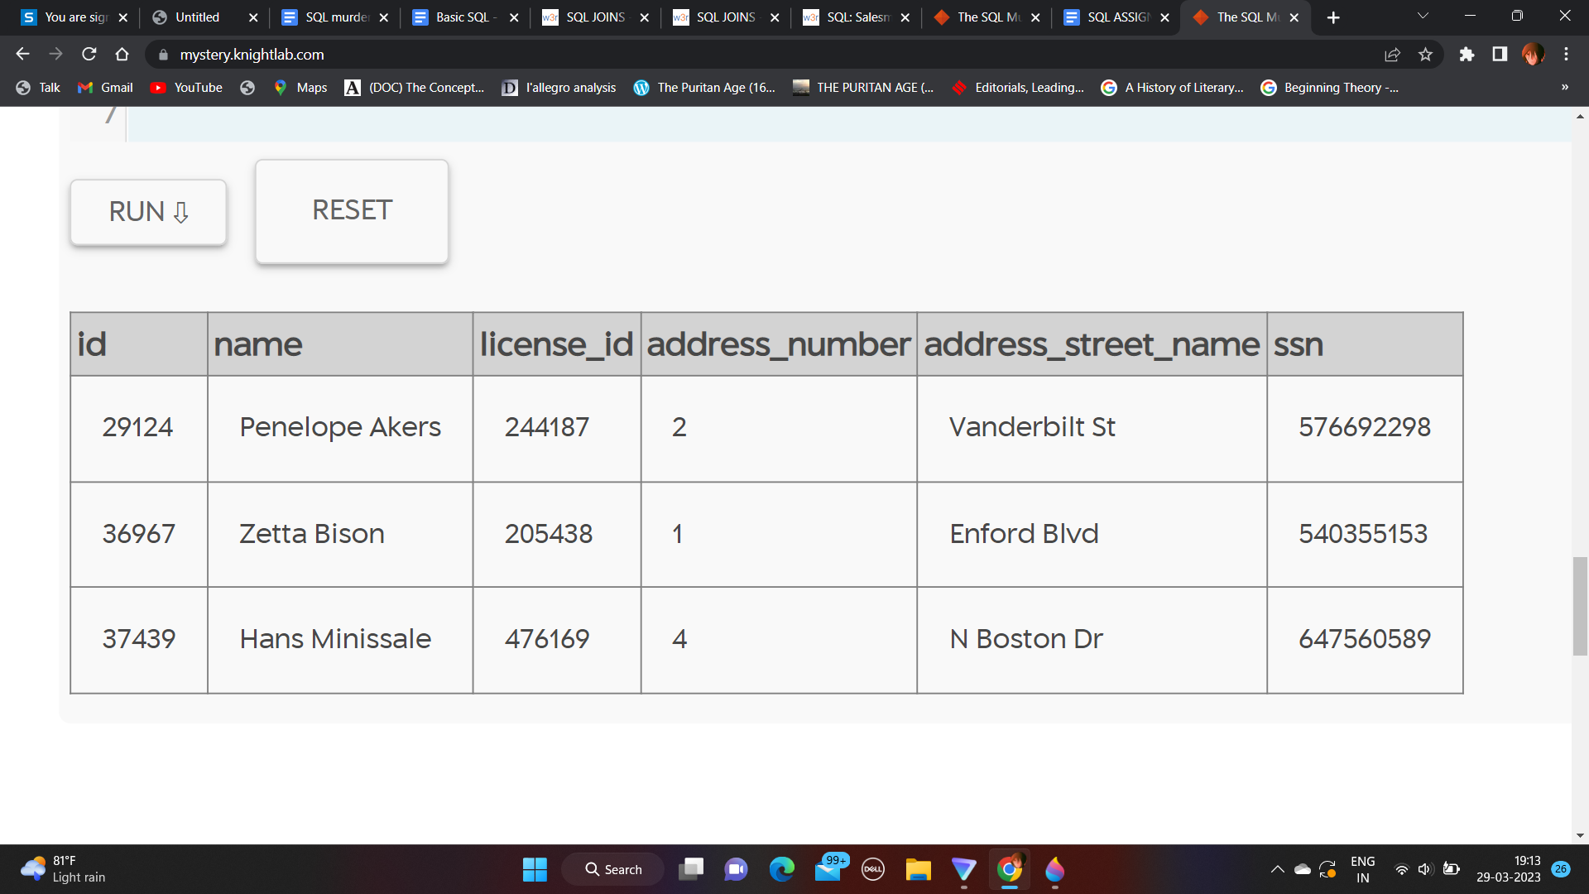

9. Selecting multiple columns and arranging them in ascending order according to height below 60.

SELECT eye_color, height, gender

FROM drivers_license

ORDER BY height > 60 ASC

LIMIT 3;

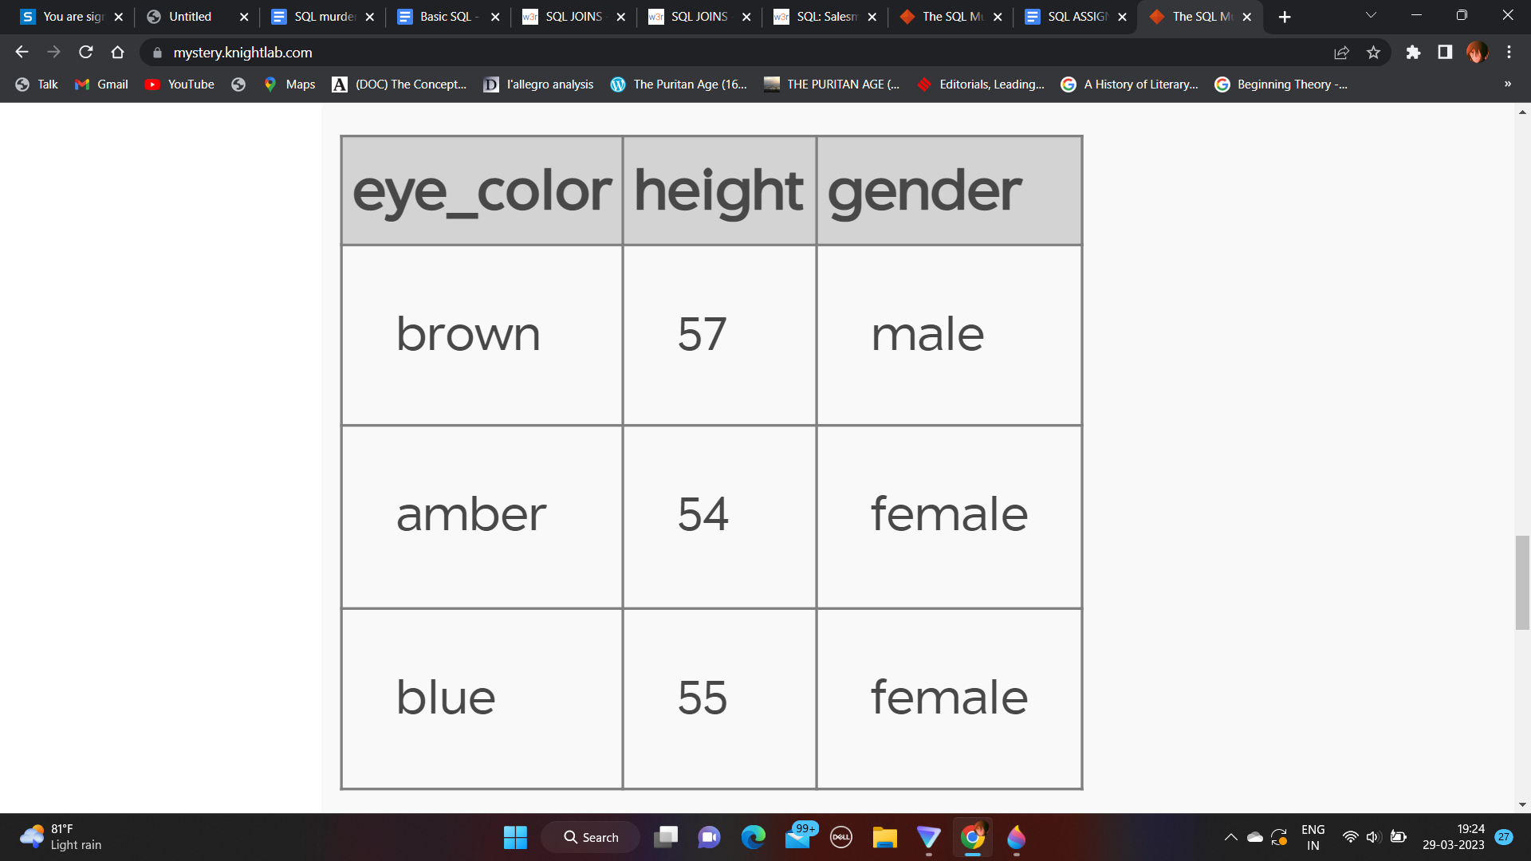

10. FInding the annual income from the income table where the income is lesser than 50000 per annum arranged in descending order.

SELECT annual_income, ssn

FROM income

ORDER BY annual_income < 50000 desc

Limit 4;

